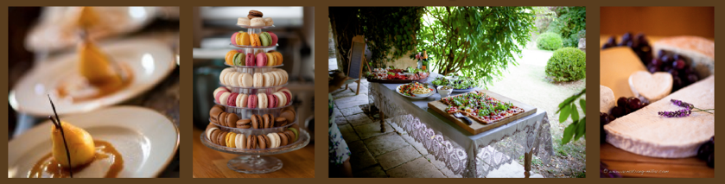

Tailored Menu

Sri Lankan influenced

Event - 11 May 2019
£40 per person

(v) = Suitable for vegetarians
(vga) = Vegan version available
(gfa) = Gluten free version available

Included in the menu price :

Canapés

Main Course – Sharing style
(served onto each table)

Dessert – Sharing style
(served onto each table)

Canapés

Please choose 4
Tomato tapenade crostini (v)
Smoked salmon, dill and mustard dressing on rye or soda bread
Curried coconut chicken skewers
Halloumi cheese and watermelon skewers with mint (gf, v, vga)
Duck and hoisin mini wraps
Melon and prosciutto skewers
Tangy Thai prawn skewers
Avacado, chilli and goats cheese crostini (v)
Mango salsa mini poppadoms
Mini roast potatoes with sour cream and caviar
Quails eggs in baskets with parmesan and paprika crunch (v, gfa)
Shredded jackfruit and plum chutney wrap with spring onions and cucumber (vg)
Blue cheese, walnuts and pomegranite on chickory leaf (gf, v, vga)
Feta and caramelised red onion tartlets (v, vga)

Main Course
Please select your meat or fish option from the below (1)
We can provide 2 meats/fish per table at supplement of £5.00 per head
(those with dietary requirements who are unable to eat the option(s) selected can have a plated alternative main option)

Chicken with prunes and pomegranate molasses
Lamb Shawarma, pulled, served on a bed couscous
Chicken with sumac za’atar and lemon
Roast Beef with savoury tomato sauce, rocket and horseradish sauce and watercress and mustard sauce
Beef and watercress salad with Nuoc Nam dipping sauce
Roast Gammon with pineapple salad (lemongrass, corriander, chilli)
Pulled lamb (either preserved lemons, honey and garlic OR Greek style)
Side of salmon with Sri Lankan curry flavours (Served as stand alone or in pieces, mixed with leaves)
Salmon salad with pickled vegetables, mint, peanuts and chilli
Salads to accompany (select 4)
Roasted Cauliflower and tahini sauce with pickled golden raisins and toasted almonds
Spelt mujadara with pomegranate onions, feta and crispy chickpeas
Roasted red beetroot with broad beans, green Harissa, yoghurt and dukkah
Pomegranate Tabbouleh - bulgar wheat, allspice, parsley, mint, dill, coriander
Baby Potatoes with Masala
Carrot and Coconut Salad
Lentils with turmeric, coriander, tamarind, lime and pineapple
Persian Coleslaw - cabbage, carrots, sultanas, cardamom, cumin, cinnamon, orange, garlic, ginger, almonds
Tamarind Rice Salad with mustard seeds, curry leaves peanuts
Bulgar Wheat with aubergine and cucumber yogurt
Chargrilled broccoli with chilli, garlic and lemon
Watermelon and feta salad with basil and red onion
Mango and coconut rice salad with mint, basil, peanuts and coriander
Barley and pomegranate salad with celery, allspice, dill and parsley
Mechouia - Turkish Salad of griddled aubergine, onions, peppers, tomatoes, chilli, garlic
Pineapple and chicory salad with chilli, mustard seeds and rocket
Green beans with hazelnuts and orange

Desserts
At table sharing style.

Each will be presented whole for cutting and sharing (select 2)
Or
We can provide per table cake stand style of minatures for £3 supplement (select 3)
Chef’s classic Lemon Tart
Fig Mascarpone Tart with Pistachio Black Pepper Crust
Big Bowl of Eaton Mess
Panacotta topped with rose jelly with lemon pistachio shortbread biscuits
Orange Almond Cake with Mascarpone
Chocolate Tart or Sunken Chocolate Cake with Amaretto Cream and Raspberries

Chef’s mini brownies
or mini carrot cake

Also Available :

Café/Coffee
(£1.50 supplement per person)

Cheese (V, Vga)

£3 per person supplement

Cheese can be served as a course at dinner or as a regional cheese board,
with bread later in the evening if you wish

Service is not included on our menu prices but we can provide service staff where required. Please discuss with us.

These menus can be subject to small changes depending on seasonality and availability of products.

The price of £40 per person is valid for 50 and over. If numbers drop below 50 the price per head would be £45.00

Megan and Claude also specialise in the hire of linens and tableware, which can be provided at extra cost. Please discuss with us if you are interested.

